Host and Environmental Factors Differentially Affect Parasite Community

Structure and Infection Dynamics in a Montane Biodiversity Hotspot

Background:
A fundamental goal of ecological research is to understand and model how processes generate patterns so that if conditions change, changes in the patterns can be predicted.
- Is biodiversity distributed non-randomly throughout space? Why?
- What factors determine the structure and patterns of biodiversity in communities?
- What factors determine infection risk among parasite communities?
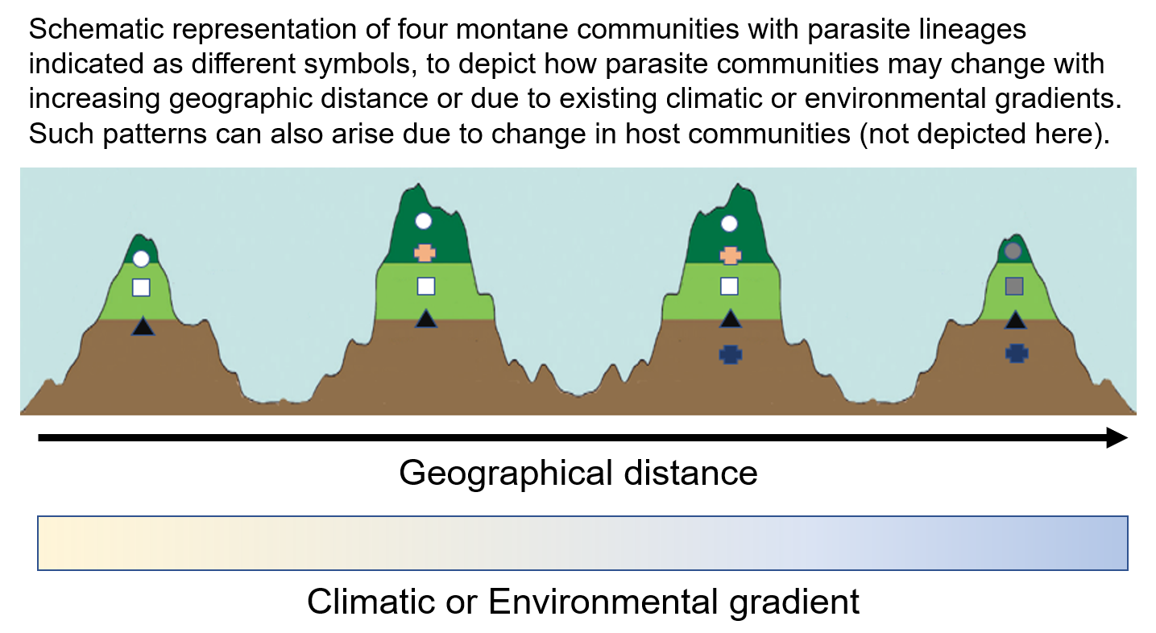
- Distance decay of similarity is a well-known and obvious pattern whereby nearby communities tend to have many species in common, whereas distant communities share very few, if any, species (see figure). But mechanisms underpinning decrease in community similarity with increasing geographical distance is less well understood.

Here we characterized variation in parasite community composition in the light of biotic and abiotic factors.
- We elucidate the contribution of host, geographic and environmental drivers in shaping parasite host (e.g., phylogeny and ecology) and environmental (e.g., climate and anthropogenic disturbance) factors on parasite phylogenetic diversity α (alpha) diversity, parasite community turnover β (beta) diversity and infection risk
- We also examine potential direct and indirect effects of elevation on infection risk
- Do these effects vary among the two parasite genera—Plasmodium and Haemoproteus?
We set out to ask these questions in a Shola sky island bird community in the Western Ghats. This a supercool system, located in a biodiversity hotspot—Western Ghats, southern India. They harbor exceptionally high biodiversity and endemism. The elevational gradients here go upto 2600m, have predictable climatic gradients and are threatened by anthropogenic fragmentation allowing us to test the effects of various biotic and abiotic factors on parasite community structure.
To do this, we chose avian malaria haemosporidian parasites as our model system. Avian haemosporidians (Apicomplexa: Haemosporida; Plasmodium and other related genera such as Haemoproteus—hereafter avian malaria) are a globally distributed group of vector-borne blood parasites that infect a wide array of bird taxa. Avian malaria caused by Plasmodium spp. is one of the most important emerging infectious diseases of wild bird populations globally. Large-scale mortalities in native wild birds have been well documented owing to the accidental introduction of Plasmodium spp. and Culex quinquefaciatus into island bird communities which had no coevolutionary history with these parasites (e.g. Hawaii and New Zealand). Our previous work (Gupta et al. 2019) has shown that Haemoproteus are host specialists whereas Plasmodium are relatively generalist parasites, so we expected different patterns of community structure for these parasites. Additionally, while several studies have studied individual effects of host factors (e.g. host phylogeny, host ecological factors) and climatic variables (e.g. temperature, rainfall) and elevational differences, very few studies have studied the integrated effects of these factors on parasite community structure and disease infection risk.
Methods:
- We captured Shola sky island birds (N=1170) using mistnets across four major geographical regions in the southern 600 km mountain range of the Western Ghats. We collected blood samples and PCR amplified 480bp of parasite cytb gene to characterize parasite infection.
- We tested the effects of different predictors on phylogenetic alpha diversity using random forest models, phylogenetic beta diversity using Generalized dissimilarity modelling and on infection risk using Structural equation modeling.
Results:
We found that 24/28 species (490 birds) were infected with haemosporidians (41.6% prevalence). Our results showed that alpha diversity of host specialist Haemoproteus parasites was primarily affected by host phylogenetic diversity whereas alpha diversity of generalist Plasmodium parasites was primarily affected by host functional diversity. While Haemoproteus beta diversity was strongly influenced by host beta diversity, Plasmodium beta diversity was primarily influenced by abiotic differences among the sites (e.g., elevation and precipitation).
Furthermore, our results revealed that elevation exerted a significant direct and negative effect on infection risk for both Haemoproteus and Plasmodium. However, for Plasmodium, elevation also exerted a significant indirect and positive effect on infection risk through its effects on other factors affecting infection dynamics (e.g., functional characteristics of the hosts and anthropogenic disturbance). Consequently, our results indicate that climatic, host and anthropogenic factors that covary with elevation can interact in complex ways to alter the underlying elevational gradient of infection risk. Our study highlights the importance of disentangling the direct effects of elevation from other host and environmental variables to improve our understanding of disease dynamics in montane ecosystems. ​​

